Marking and Feedback Policy

Marking and Feedback
The aims are to:
- Provide clear guidelines on the Llangynwyd Primary School’s approach to assessment
- Establish a coherent approach to assessment across all subjects
- Provide a system which is clear to students, staff and parents
- Establish a consistent approach to marking learners’ work so that students feel valued and have a clear understanding of how well they are doing and how they can improve their learning to reach their potential

Principles
Llangynwyd Primary outlines three key questions which underpin high-quality marking and feedback:
- Where am I with my learning?
- Where am I aiming to get to with my learning?
- How do I get there?

Manageable, Meaningful and Motivating Marking
Manageable: marking practice is proportionate and considers the frequency and complexity of written feedback, as well as the cost and time-effectiveness of marking in relation to planning and teaching lessons.
Meaningful: marking varies by age group, subject, and what works best for the pupil and teacher in relation to any particular piece of work. Teachers are encouraged to adjust their approach as necessary and to incorporate the outcomes into subsequent planning and teaching.
Motivating: Marking should help to motivate pupils to make progress. This does not mean always writing in-depth comments or being universally positive: sometimes short, challenging comments or oral feedback are more effective. If the teacher is doing more work than their pupils, this can become a disincentive for pupils to accept challenges and take responsibility for improving their work.
An important element of marking is to acknowledge the work a student has done, to value their efforts and achievements and to celebrate progress. There are many ways to do this without extensive marking and too much feedback can take away responsibility from the pupil, detract from the challenge of a piece of work, and reduce long term retention and resilience-building.
Pupils should be taught and encouraged to check their own work by understanding the success criteria, presented in an age appropriate way, so that they complete work to the highest standard.

Marking in practice
Key marking
Not all work should or can be marked in depth. Indeed, the use of meaningful self and peer assessment would lighten the marking load but also enrich the dialogue between teacher and student about the student’s learning. Focus marking should take place during a Bubbles Activity. While in the Bubble activity, Collaborative Group Feedback can be given and the one sheet template will be used to identify common strengths and common areas for development. ( Appendix 1) (An activity led by an adult). Igloo and Mission will be a hybrid of teacher marking using the codes ( Appendix 2) and self/peer assessment. This will vary and be dependent on the age and ability of the children.
- During extended pieces of writing, Success criteria will be shared with students so that they can be involved meaningfully in the process of marking and feedback, knowing what constitutes good learning and how learning can be improved
- During other work, teachers or adults in the class will give verbal feedback and use the correct symbol to show that feedback has been provided and that children use green pen to take learning forward
- When using Bubble, Igloo and Mission tasks, teachers will focus mark their bubble group.
- Students must be given the opportunity to respond to the marking and feedback in order to show understanding of how they can improve their learning through redrafting, corrections, extension work or applying ideas to new situations or problems. They will respond in Green Pen to shown they have responded to the teachers comments.
- Feedback or marking comments should surround the 3 C’s. The feed forward question should focus on one of the following :
  - Consolidation Question – to consolidate learning/skill developed in the lesson
  - Challenge Question – to move learning forward
  - Coaching Question – to scaffold any misconception or teach/coach difficulty the learners have.
- Teachers are responsible for regularly recording marks or comments for students’ work

Peer and self-assessment
Other work can be marked with a lighter touch. However, the use of peer and self-assessment should also be encouraged since, when used effectively, this deepens students’ understanding of learning objectives, success criteria and what actually makes good work and learning. For this to work in a meaningful way, teachers need to model good learning and fully share success criteria in language which students understand. Feedback from peers should be about the work, not about the person, and it should be focused on specific, kind and helpful comments which will enable learning to progress. Learning Objectives will be shared with the class but not recorded in pupils books and success criteria, where possible and appropriate, should be child generated and shared with the class. This does not mean stuck in books but displayed in class on the CTouch, whiteboard or paper. The exception to this, is during the Hot task where a clear and explicit success criteria is evident in pupils work. Pupils will use a traffic light to self or peer assess each other work using:

- Green – mastered the activity
- Amber – achieved it but not fully confident
- Red – More practise/help or more consolidation needed.

Presentation of work
It is important that students are encouraged to present their work in an acceptable and professional manner. The following are minimum expectations for written work:
- Titles underlined with a ruler
- To the left of the page and on top.
- No incomplete work or gaps in the books
- Where work is missed it is caught up as quickly as possible
- Use blue pen or pencil
- Diagrams and tables should be drawn with pencil and ruler
- Any errors should be crossed out in a single line and not scribbled out.

Codes

Teachers will use a series of codes to help learners move their learning forward. These codes are used as abbreviations and will be known and understood by all learners and staff. These codes will be present in each book and displayed in every classroom or working area. Teachers are not expected to write in depth.

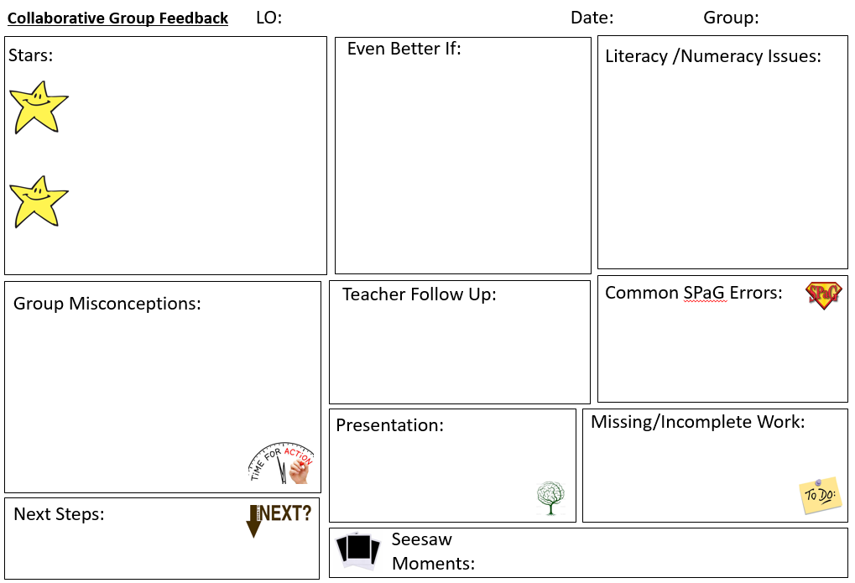

 | I have achieved the learning objective
 | I have mastered the learning objective
 | Check it dot –My teacher will give me time to go back and put it right.
____ | My teacher will underline spelling mistakes that need correcting - I will choose 3 of these words to practise.
C | I have confused my capital and lower case letters - I will go back and correct.
P | I have not used the correct punctuation - I will go back and correct.
/ | I have not used finger spaces between my words.
// | I should begin a new paragraph here.
abc | I need to improve my handwriting/presentation.
V | I have talked with my teacher to extend to my learning.
GF | I have received collaborative group feedback.
S | I required support to complete this activity.
I | I completed the task independently.
GW | I worked as part of a group to complete this activity.
 | I need to move my learning forward by…
 | I use green pen/pencil to edit and improve my work.
 | Children will colour the traffic light to self and peer assess learning
Our Feedback Codes

