- Purpose and Intention of Policy
Background:
The 2020 pandemic, unprecedented and unplanned for, has brought about challenges for primary school teaching and learning which previously and predominantly took place in large classrooms, under the instruction of teachers, within a highly structured day. The sudden need to adapt to distance learning allowed limited time for teachers to implement detailed procedures; however, as schools reopen to more pupils from
1st September 2020, there is a requirement to ensure a more consistent, formalised and structured approach to blended and distance learning, in the event of local downs or classes self-isolating.

Welsh Government, Central South Consortia and Bridgend CBC have all produced guidance and documents that states schools need to begin to think about learning and teaching for the academic year. Schools should consider “ a blend” of in school and out of school learning driven by a singular curriculum. Practitioners will need to think how learning outside the classroom supports the valuable and limited contact time.

Statement of intent:
This policy will outline the types and methods of blended learning; provide guidance on the approach to blended learning that should be taken by staff, pupils and parents; and, aim to ensure consistency of approach across all departments in the school. Consequently, Llangynwyd Primary School will continue to provide engaging, exciting and challenging learning opportunities, both in school and at home, which result in
ambitious, capable learners, committed to lifelong learning.

Additionally, the well-being of pupils and staff is a significant consideration; it is recognised that learning can give a sense of purpose and achievement which is good for mental well-being.

The policy aims to ensure a seamless and efficient blend of in-school and at-home learning, thus allowing pupils to make progress while staff workload remains manageable.

Definition of blended learning:
"At its simplest, blended learning is the thoughtful integration of classroom face-to-face learning experiences with online learning experiences." [Garrison and Kanuka, 2004]. At Llangynwyd Primary School, this means that time spent learning in the classroom will introduce key concepts, new content and skills; address misconceptions; answer questions; and, set clear expectations. When pupils are at home it will involve a variety of online methods which include teacher videos, presentations and interactive tasks using Seesaw, Google Classroom, HWB and other online programmes.
However, it should be noted that the learning that takes place at home will take a variety of forms and will not be restricted to online provision.

- Scope:

This policy applies to all teaching and non-teaching staff at Llangynwyd Primary School.

- Guidance:

Types of Blended Learning found at Llangynwyd Primary School:

- Face to Face Learning:
This is the traditional form of teaching and learning that took place prior to the COVID 10 Pandemic. Teacher centred method of learning that takes place in a classroom setting, in person, in school.

- Station Rotation
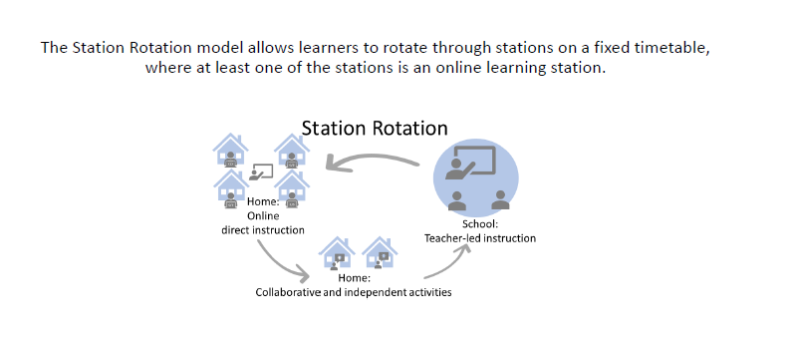
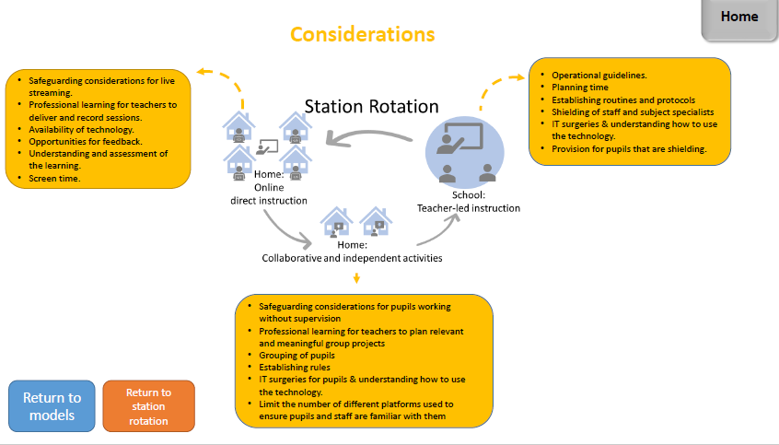

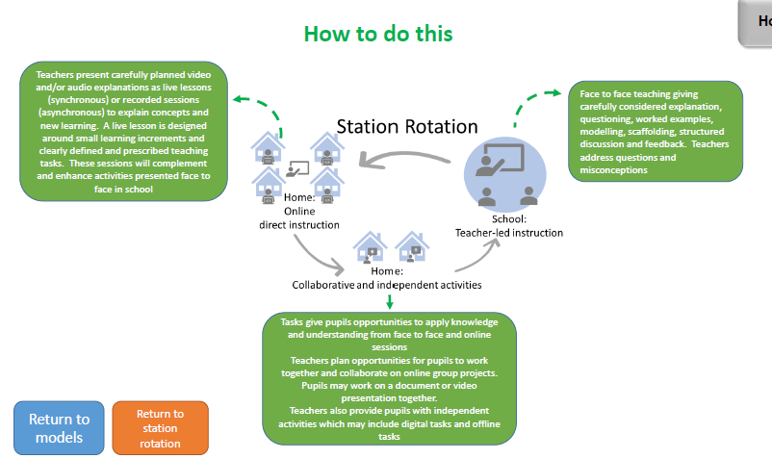

- Online Learning Platforms
The School’s platform for sharing online resources and setting work will be Seesaw in Foundation Phase and LRC BASE Classes with links to other resources shared.
In Key Stage 2 it will be through Seesaw with links to Google Classroom. Pupils will also be able return/submit completed tasks through this platform. It is recognised that a considerable amount of
engaging and effective work has been set through platforms such as YouTube. The continued use of these platforms is consistent with this policy and to be encouraged. However, for consistency (and to minimise the number of emails pupils receive) resources and links associated with the work on alternative platforms should be posted on Google Classroom (KS2) and on Seesaw ( FP and LRC BASE Classes)

I. Asynchronous Learning – is the school’s preferred method of video lessons.
Asynchronous learning is learning that doesn't necessarily happen at the same time for the teacher and the pupils. There is no real-time interaction; the learning resources are created and made available for pupils to use later on. The school appreciates that if pupils are self-isolating, parents may need to work from home and live synchronous learning may not always be convenient.
The main features of asynchronous learning are:
  - resources and activities delivered online, e.g. through Google Classroom;
  - recorded lessons/video instruction/podcasts;
  - flipped learning - pupils engage with material before discussions in class.

- Hard Physical Copies of work
Using paper packs at home replicates what the learning process looks like in school. At Llangynwyd Primary School, hard copy physical resources include:
- Paper packs and work booklets
- Textbooks

- Responsibilities

Who | Responsibilities
Leadership | The role of the Senior Leadership Team is to:  ● develop, monitor and evaluate the whole school strategy for blended and distance learning;  ● communicate with, and provide support to, departments, staff, pupils and parents, to ensure effective implementation of blended and distance learning;  ● provide opportunities for appropriate CPD training to ensure that staff are able to deliver blended and distance learning effectively;  ● ensure accountability of the blended and distance learning process, through self evaluation.
Teachers | The role of the teacher is to:  ● continue to strive to deliver consistently excellent lessons in accordance with the Teaching & Learning policy;  ● engage with CPD training to ensure proficiency in delivering effective blended and distance learning;  ● collaborate with colleagues to design and develop high-quality blended and distance learning experiences for pupils, in accordance with school plans  ● plan and deliver blended and distance learning experiences for all pupils, including those with additional learning needs, taking into account Individual Development Plans ( IEPS) and ensuring that pupils’ needs are fully catered for;  ● communicate with, and provide timely feedback to, pupils in line with the School’s Marking and Feedback Policy;  ● .carefully monitor pupils’ work completion and deadline compliance;  ● communicate with pupils and parents, as appropriate, as per the Behaviour and Discipline Policy, to ensure engagement and progress with the blended and distance learning experience.  Teachers will not be able to respond to multiple requests for assistance. Questions can be asked at the next face-to-face session with the teacher. If unsure about what to do with a task, pupils should: read questions and instructions carefully; research the answer to the question; or, collaborate with a friend/another pupil/classmate. If, while learning at home, a pupil has a problem that cannot be solved, then school should be contacted and a response will be made within 24 hours on a week day.
Non teaching Staff  LSA, LSO , SSO SSA | The role of learning support staff is to:  ● provide support and assistance to teachers,  ● assist with implementation of pupils’ Individual Development Plans so that their needs are fully catered for through blended and distance learning.
Pupils | Pupils should:  ● dedicate appropriate time to distance learning, in order to complete the tasks set by the due date;  ● check SEESAW/Google Classroom for information on tasks, assignments and resources daily, throughout the school week;  ● identify a comfortable and quiet space to study/learn;  ● engage in all learning set with academic honesty;  ● submit all tasks and assignments in accordance with provided timelines and/or due dates;  ● appreciate that when working at home, teachers will be delivering lessons every day at school.  Teachers will not be able to respond to multiple requests for assistance. Questions can be asked at the next face-to-face session with the teacher. If unsure about what to do with a task, pupils should: read questions and instructions carefully; research the answer to the question; or, collaborate with a friend/another pupil/classmate. If, while learning at home, a pupil has a problem that cannot be solved, then school should be contacted and a response will be made within 24 hours on a week day
Parents/carers | Parents/Carers should support their child/ren in their learning by:  ● providing an environment conducive to learning;  ● engaging in conversations about resources, tasks and assignments provided/posted;  ● monitoring time spent engaging in online and offline learning;  ● helping to provide emotional balance through ensuring ample room and time for reflection, physical activity, conversation, rest and play.

Engagement:
For a blended learning approach to be effective, it is of critical importance that all pupils engage with the process. Therefore, pupils must have a secure understanding of what they have to do and by when.
Differentiation, a comprehensive overview and clear instruction will be of critical importance, to enable pupils to balance work completed in school and at home.
We expect that all pupils will engage with this approach to teaching and learning and exceptional levels of engagement can be celebrated by each class in already established ways. It needs to be made clear to pupils that work is not “optional” and we expect tasks to be completed. Clear deadlines should be set to give pupils an explicit understanding of what is required, by when.
We recognise that pupils may be having difficulty in adapting to the new way of working or are struggling with barriers to learning, e.g. lack of space to work at home; unreliable broadband or limited ICT provision; etc. Therefore, it is important to try and establish what these barriers are and how we might help to remove them. Established lines of referral (Class Teacher – DHT – HT) should be used as necessary. Communication with pupils in school and with parents at home will be an important way of addressing these issues.

Expectation of learning per day:

Foundation Phase
Subject | Number of lessons per day

Key Stage 2
Subject | Number of lessons per day
Literacy | 1 x 1 hour lesson per day
Mathematics | 1 x 1 hour lesson per day
Topic based | 1 x 1 hour lesson per day
SUMDOG /Big Maths | 1 x 30 minutes quick fire lesson per day
Reading carousel which includes ( Comprehension, Spelling, Handwriting, Phonics ( RWI) | 4 x 30 minute activities per week.

GOLD - BASE CLASS
Subject | Number of lessons per day
- Handwriting Without Tears session (Literacy) daily | Daily
- Story and related activities | 2 x week
- A speech and language focus activity (2x week) | 2 x week
- Maths activity (Preferably Numicon however this is difficult without the children having access to physical resources) daily | Daily
- Calming activities (Cosmic Yoga this term to mimic what's going on in class) | Daily
- Bucket | Daily
- SUMDOG | Daily

YELLOW - BASE CLASS
Subject | Number of lessons per day
- Handwriting Without Tears session (Literacy) daily | Daily
- Story and related activities | 2 x week
- A speech and language focus activity (2x week) | 2 x week
- Maths activity (Preferably Numicon however this is difficult without the children having access to physical resources) daily | Daily
- Calming activities (Cosmic Yoga this term to mimic what's going on in class) | Daily
- Bucket | Daily
- SUMDOG | Daily

As and where appropriate – booklets may be the best way to support our BASE children to mimic the activities that happen in school.

This policy will be under constant review during a pandemic and parental, pupil and staff feedback will be sought to ensure it remains fit for purpose.

